Welcome Back
Hope you all had a lovely Easter break. We look forward to working with you again this term.
Science Week 2019: Going Wild!
The week beginning the 18th March was Vicarage Primary School’s Science Week. The theme this year was Going Wild which linked with our school wide ‘Good to Grow’ topic. We had a range of animals in school which children were able observe and handle. They learned about animals and how to care for them. The Early Years and KS1 children attended an assembly by the Wiggly Wild Show. They had the opportunity to learn and observe up close a bearded dragon, corn snake and tarantula. KS2 had an assembly by Dr Stu. He taught pupils about reptiles. Members of staff and children had an opportunity to touch Geoff the boa constrictor, which was the highlight of the assembly.
“This is the best week ever." Filip 2P

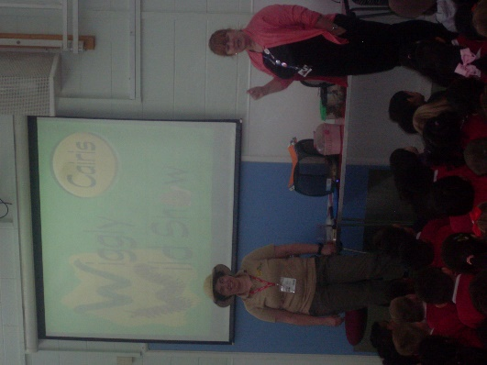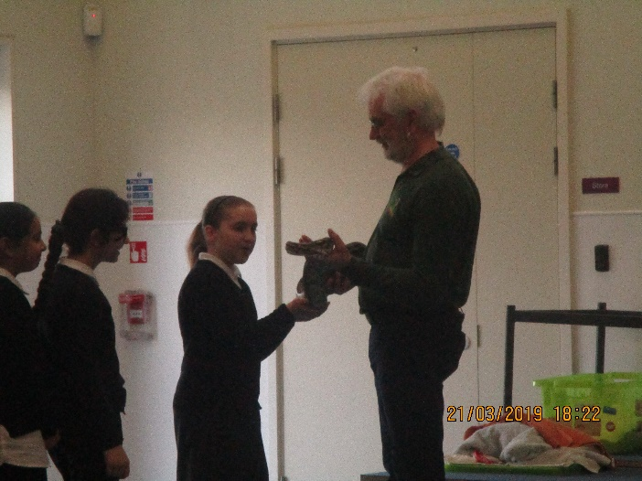

EYFS: The week started with the delivery of chicken eggs in an incubator to Reception classes. The children were very excited and predicted what was inside, counted them and made observational drawings of the eggs. The children in Nursery were very lucky as one of the eggs hatched whilst they were in class. This was recorded, which was shared with the other classes. Some of the nursery children’s responses were; “It’s hatching! It’s hatching!” “It’s going to get out of the egg.” To observe the wonders of life was an amazing experience for them. During the week, children also learned about the lifecycle of a chicken, a butterfly and plants.
“They changed and one of them got fat and was growing.” Kingsley class RD.
“I learned how they grow and their wings turned white. They are going to turn into big chickens and have eggs.” Caspar class RM.
“I touched it and it felt soft.” John RD.
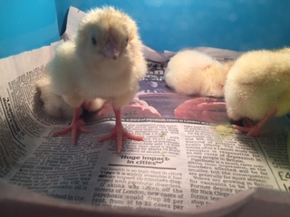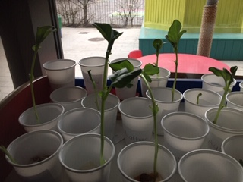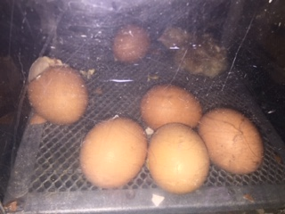

KS1:
Year 1 had a workshop on animal’s Super Senses and Year 2 had workshops on Variations in animals. Children learned about the animals they were handling.
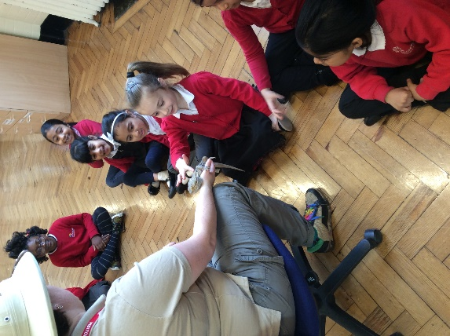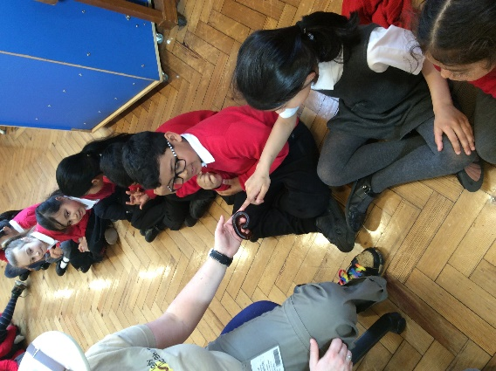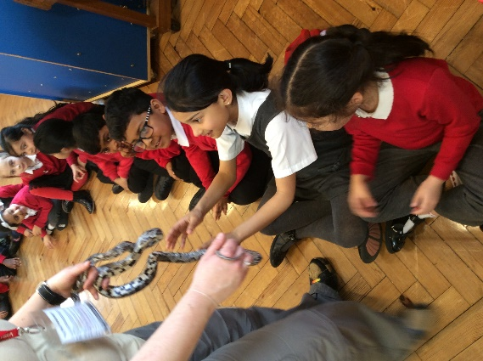
In class, Years 1 and 2 focussed upon growing plants and the changes that occur in animals as they grow. The children grew their own bean plants.
“I enjoyed the plants when it grew. Learning about science helps me to be clever.” Garion 1K
“I liked when we felt the snake. It shocked me because it felt smooth. I thought it would be bumpy but it wasn’t at all. I learned some animals can be nice but some can be dangerous. I learned where some snakes come from.” Niniola 2P
KS2:
Year 3 had a workshop by Animals UK who brought in a range of reptiles, mammals and invertebrates for children to learn about and have the opportunity to handle. The children were very caring and kind towards the animals and fascinated by the boa constrictor.
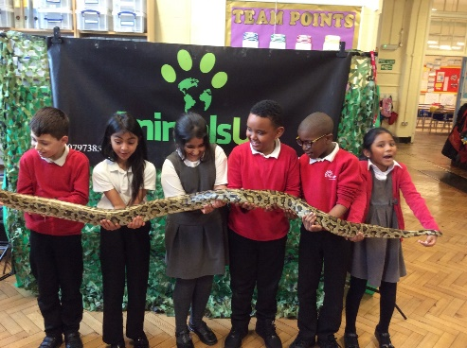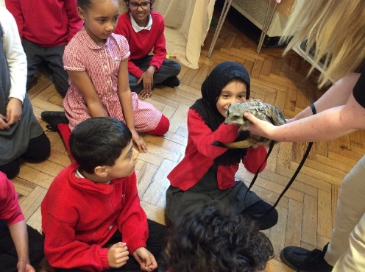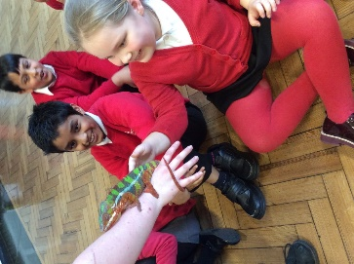

In class the children focussed on plants and plant parts, including the function of these plant parts. They completed an investigation using celery to observe the transportation of water through the stem.
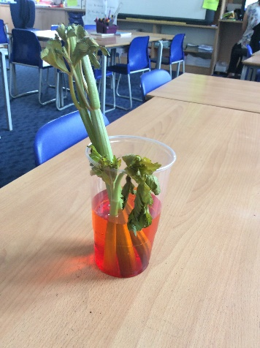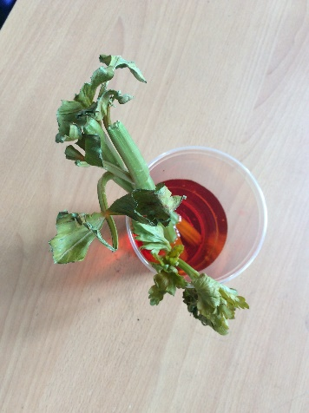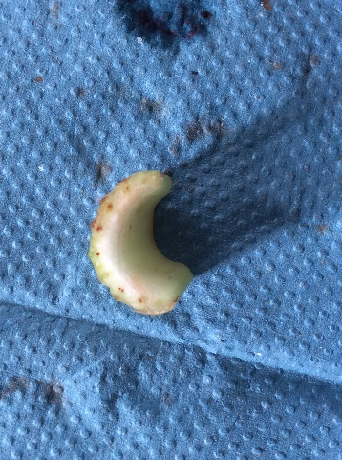

Year 4 learned about teeth and digestion. Their investigation focussed upon the effects of different liquids on teeth by using eggs to represent dental enamel.
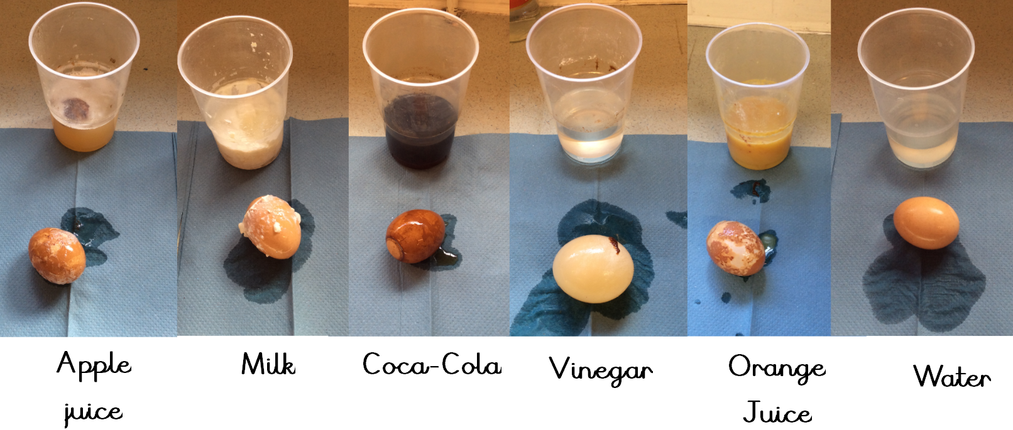
“We did a celery experiment and we got to touch a real snake. I learned that not all animals are scary and that they are just natural and can be gentle.” Anaelle 3B
“Thank you for getting us a snake. I have never held one before but I was really brave. That was awesome.” Zander year 4B
Year 5 and 6 classes had a workshop by Dr Stu where they learned about a range of animals. They were also able to touch Geoff the boa constrictor in assembly.
The children had the opportunity to observe the growth and metamorphosis of caterpillars. They have the caterpillars in class who are at the moment are in the pupa stage. Over time they will emerge from their chrysalises as butterflies.

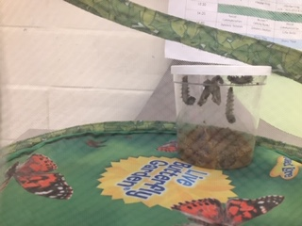

Pyjama day pictures- Red Nose Day 2019
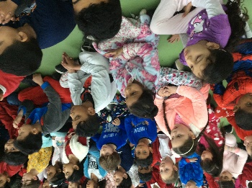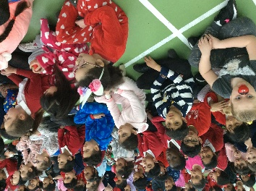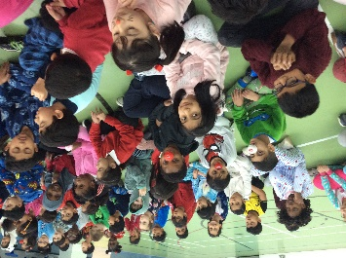
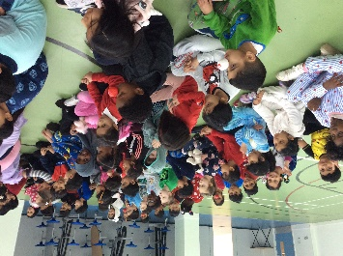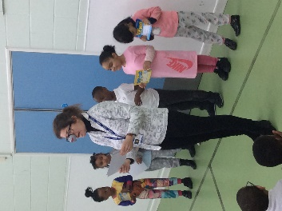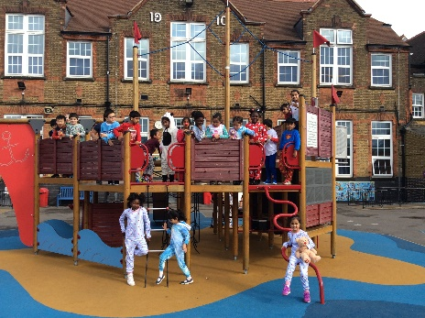

This year our school decided to have a fun, lazy day and came to school in... pyjamas to mark Red Nose Day. Some of our pupils also wore red noses and brought in cuddly toys.

"We were fundraising and having fun at the same time!" - Ade 4C

"The pupils were secretly laughing at teachers who wore their pyjamas to school! This was very unusual!" - Mara 4U

"We are glad that everyone's participated in this fun day!" - Khojista 4U

The School Council would like to thank you all for supporting this worthy event!

Whole School Events

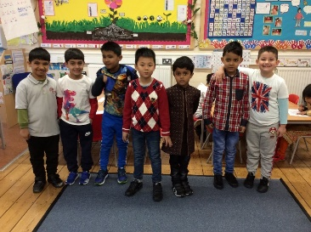
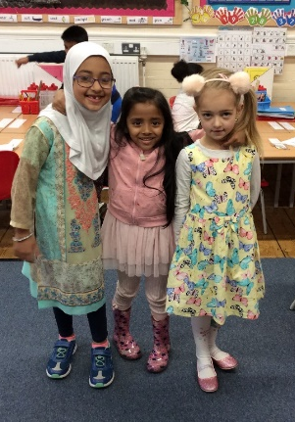
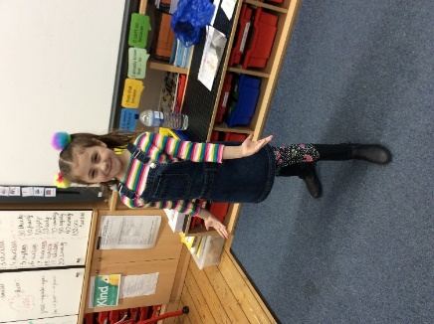

On Friday 22nd March, to mark Holi (the festival of colour), children and staff came dressed in colourful clothes. During the day, children learnt about Holi and how it is a festival celebrated by those who follow the Hindu faith.
To mark Easter, we held an Easter bonnet parade in each phase. The children created beautiful bonnets which they then paraded in front of their year groups. The best bonnets were selected and prizes were awarded.
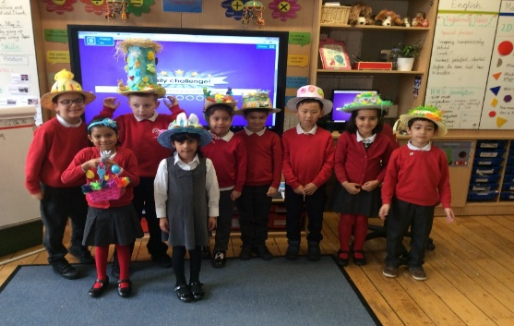
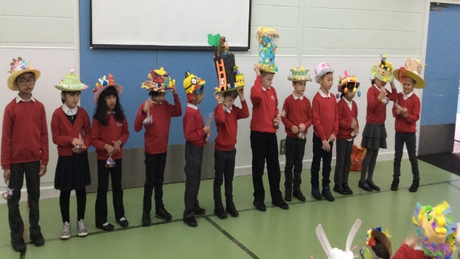

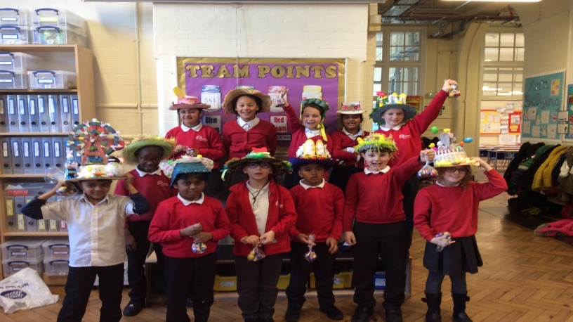

Autism Awareness Week – 29th April – 3rd May 2019
Vicarage will be holding our annual Autism Awareness week, the week beginning Monday 29th April 2019. This is a national event set up by the National Autistic Society to raise awareness of the condition and raise money to find campaigns to help those with Autism. Despite affecting over 1 in 100 people in the UK, there are a lot of myths and misconceptions surrounding autism. According to the NHS, Autism Spectrum disorder (ASD) is a lifelong developmental disorder that affects how people perceive the world and interact with others. Autism is on a spectrum, meaning the condition will affect individuals in different ways.
At Vicarage, throughout the week a number of events will take place. The week will start with assemblies for all pupils. Further work will be done in class through PSHE and P4C lessons. On Thursday 2nd May at 2:00pm there will be a parent workshop (Strategies for Supporting Emotional Regulation) and on Friday the 3rd May, there will be a Spectrum Non-uniform Day to raise money for The National Autistic Society. We are asking for a 50p donation.
Training for Parents
Vicarage Primary will be hosting a peer – led course that supports parents to develop emotional resilience in their children, by exploring a range of themes including understanding feelings, managing behaviour and setting boundaries. The course is accredited by the Open College network.
The course will run every Tuesday from 30th April until 02nd July from 1:00pm until 3:00pm.
If you are interested please speak to Mrs Ali, the Family Support Worker, for more information and booking a place on the course.

Food Bank
We are still collecting food for The Well Food Bank – please send any unperishable foods you may have to the school office.

Dates for your Diary
Friday 26th April – Parents Coffee Morning – Focus : Vicarage PTA
Friday 3rd May – Non Uniform Day for Autism Awareness week
Monday 6th May – School Closed – Bank Holiday
Friday 24th May – Last Day of Term 5
Monday 27th May – Friday 31st May – Half Term
Monday 3rd June – Back to School for all pupils – Term 6

Mrs S Khan
Head Teacher

