Year 6 Barcelona Visit

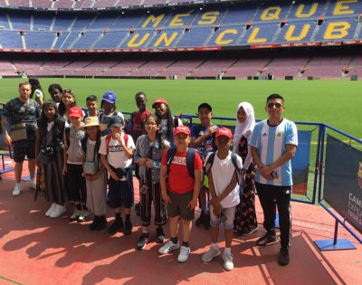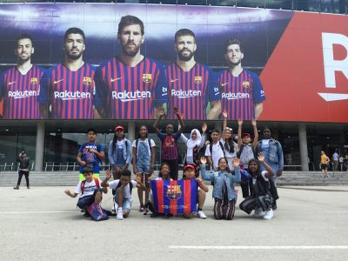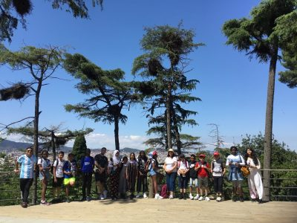

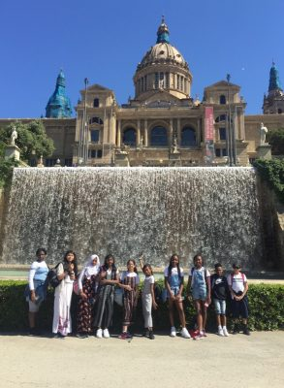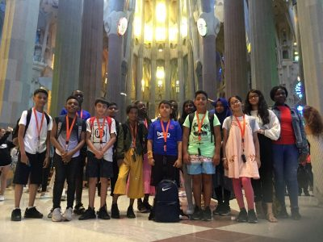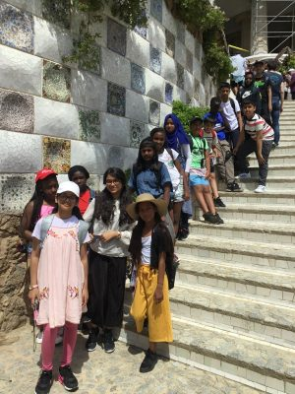

We had the pleasure of holding our very first overseas educational visit earlier this term. Fifteen Year 6 pupils accompanied by Mrs Khan, Miss Bhuta, Mr Griffin and Mr Puruncajas spent a week in Barcelona, Spain. The visit had a Language and Art focus. At Vicarage, we teach Spanish and this was a great opportunity for the pupils to apply their knowledge and understanding of the language within a real context. Pupils also had a wonderful opportunity to visit many famous landmarks in the city, including the church of The Sagrada Familia, Park Guell and Nou Camp.

Stephen Timms (MP) Visit

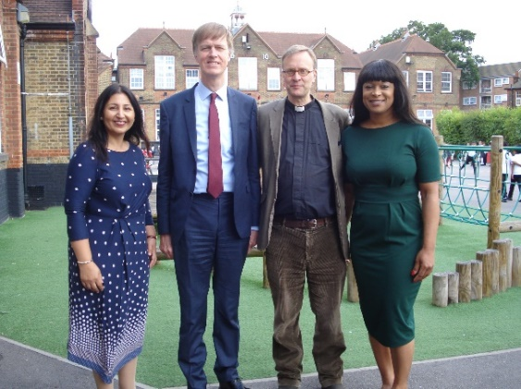

On Thursday 20th June, we had a visit from Mr Stephen Timms (MP for East Ham). He had been invited by the Head Teacher to discuss and see for himself the provision for SEND pupils at the school following concerns that some parents of SEND pupils had shared with him. The Chair of Governors, Revd Peppiatt, was also in attendance. They discussed with the Head Teacher and the SEND team some of the challenges that the school, as well as schools nationally have been facing around meeting the needs of SEND pupils. This was followed by a learning walk to look at the provision at Vicarage. They saw pupils in class, working with their one to one support in the sensory and soft play rooms, as well as outside in the playground during breaktime.

Mr Timms was impressed with what he saw. The positive feedback is a testament to the hard work of all staff at the school.

Panathlon 2019
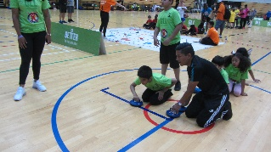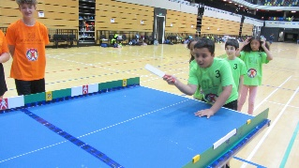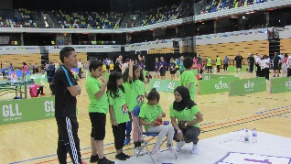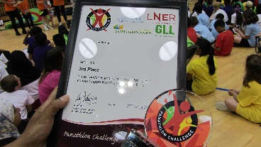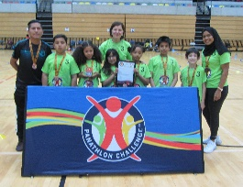
On Tuesday 2nd July, 6 KS2 pupils (Hasher 5S, Drin 5P, Shabab 6S, Abeer 3A, Taiijah 3M, Ariana 5S) took part in the Panathlon challenge at Copper box arena. The competition involved twenty four schools from across London and consisted of 6 challenges. It was a tough competition but our pupils did extremely well, finishing in 3rd place overall, winning a trophy and medals for themselves. A big well done to all the pupils on their fantastic achievement.
Summer Fete

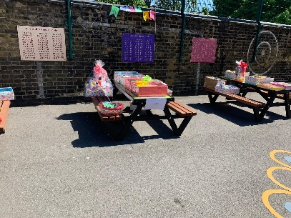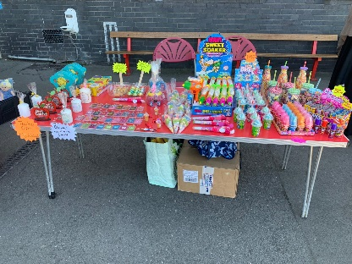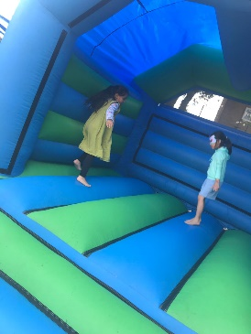

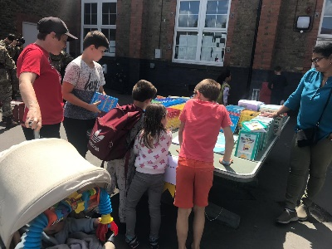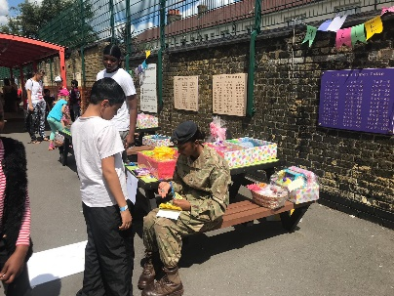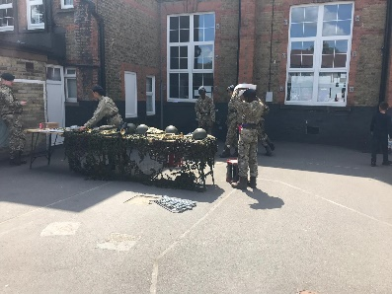

On Saturday 22nd June, Vicarage held its second PTA Summer Fete. There were bouncy castles, face painting, performances from the local cadets, as well as numerous food and activity stalls. We managed to raise over £800. The event was organised by the PTA and Mrs Ali, our Family Support Worker, who have all worked hard to organise the event. Our thanks go to everyone who organised and attended the event.

Sports Days

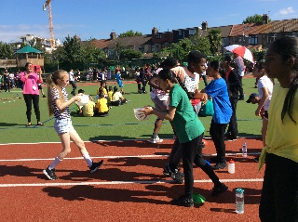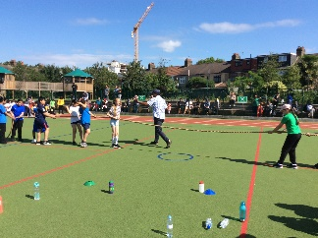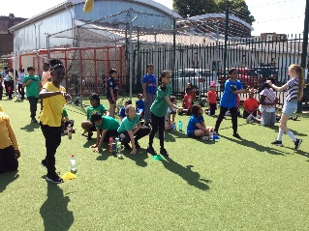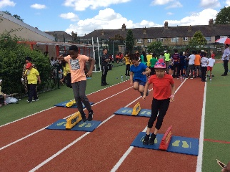

On Tuesday 2nd and Wednesday 3rd July, Vicarage held Sports Days for all year groups. Thank you to all the friends and family who came to support the children. Thank you also to Mr Griffin, our PE Lead, for organising the Sports Days.

Art Exhibition 2019
Vicarage Primary School took part in the ‘Art Matters’ exhibition at the University of East London in Docklands. The school presented a range of work by pupils from Reception to Year 6.
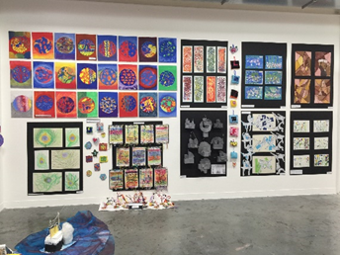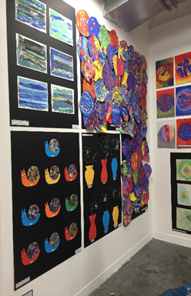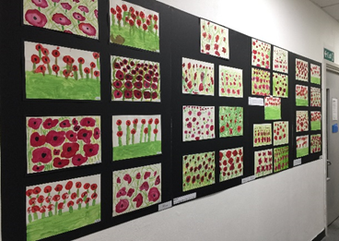

Year 6 pupils also had an opportunity to visit the exhibition to see their own art work as well as work from other Newham schools.

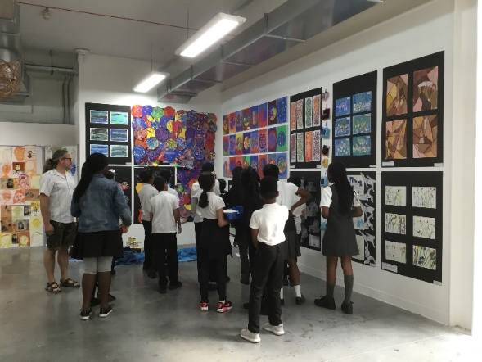
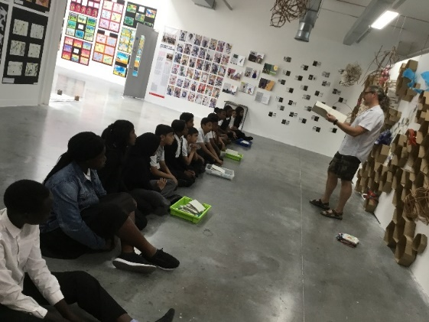

Bike Club Update
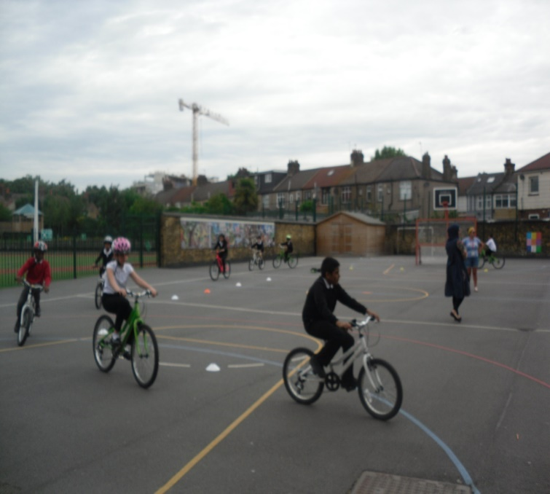

It has been a very good year for our bike riders. Firstly, we had a very exciting and hardworking group from year 4 who learnt about bike maintenance and how to be safe on the roads. Next, our Year 1 pupils had training to ditch their stabilizers and learn to balance themselves. Many of the pupils can now confidently ride their bikes. Our Year 5 pupils had the opportunity to take part in a bikeability course which helped to develop their confidence levels. Pupils received certificates and badges for completing bike proficiency Level 1 and 2.

Farewell
At the end of term we will be saying a sad farewell to our Year 6 pupils who will be leaving primary schooling. They have been a wonderful group of pupils who have worked really hard all year. We will miss them a lot and wish them all the best at secondary school.

We will also be saying goodbye to a number of staff. Miss Sadia is moving out of London as is Miss Chavda, who is getting married over the summer. Mr Munshi is taking a break from teaching for a little while. Miss Choppy, Miss Sam and Miss Islam will be taking up teaching posts in other schools in Newham. Miss Sangha and Miss Patel, our admin apprentices in the office will be leaving, having completed their training at the school.

It is with mixed emotions that I would like to inform you that after seventeen years at Vicarage, Mrs Hussain, the Deputy Head Teacher, is leaving to take up headship of a primary school in Redbridge. Mrs Hussain has built positive relationships with both staff and families over these years. Having appointed her as my deputy three years ago, she has worked very closely with me and the leadership team to take the school from strength to strength. She, as will all the staff leaving, will be greatly missed by everyone at the school.

We want to say a big Thank You to all the staff leaving for their many years of service and wish them all the best for the future.

Dates for your Diary
Wednesday 10th July – Year 6 performance to parents – 5pm
Thursday 18th July – Class parties - pm
Friday 19th July – Last day of Term 6 and academic year for all pupils
Monday 2nd / Tuesday 3rd September – Teacher Training Days
Wednesday 4th September – Back to school for pupils from Years 1-6
Monday 9th September – Back to school for pupils in Reception classes
Monday 16th September – Back to school for pupils in Nursery
Friday 18th October – Last day of Term 1
Monday 22nd – Friday 26th October – Half Term
Monday 28th October – Teacher Training Day
Tuesday 29th October – Back to school for all pupils – Term 2
Mrs S Khan
Head Teacher

