Welcome to Vicarage Primary School’s history page. If you have any other information, stories or photographs please get in touch at info@vicarage.newham.sch.uk

Vicarage Primary School started life as Vicarage Lane Infants and Girl’s school. It has since then developed from a small school of just over 200 to a thriving inner London school of over 800 students. Its walls have seen the reign of Queen Victoria, King Edward VII, King George V King Edward VIII, King George VI, and Queen Elizabeth VII.

At Vicarage Primary School we are fortunate to have some old logbooks and registers dating all the way back to when the school opened. They have some wonderful but also haunting memories. These precious artefacts contain the happiest of memories such as new students arriving, coronations of King’s, Royalty visiting and expansions of the school. However, they also contain memories of dark times such as German bombings during the war, evacuees being sent off to different areas of England and outbreaks of illness such as pneumonia and measles. They also show the hard ships of the times and how grateful we should be living in such a modern technological world. There are examples of children needing to be carried to feeding banks in Barking, as they were too weak to walk themselves. During the early days at Vicarage, attendance was also affected by winter times where children could not come to school because they did not have boots.
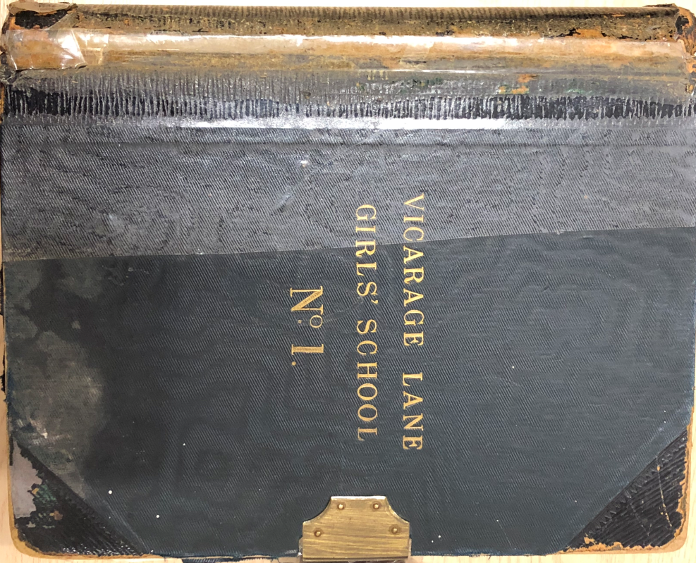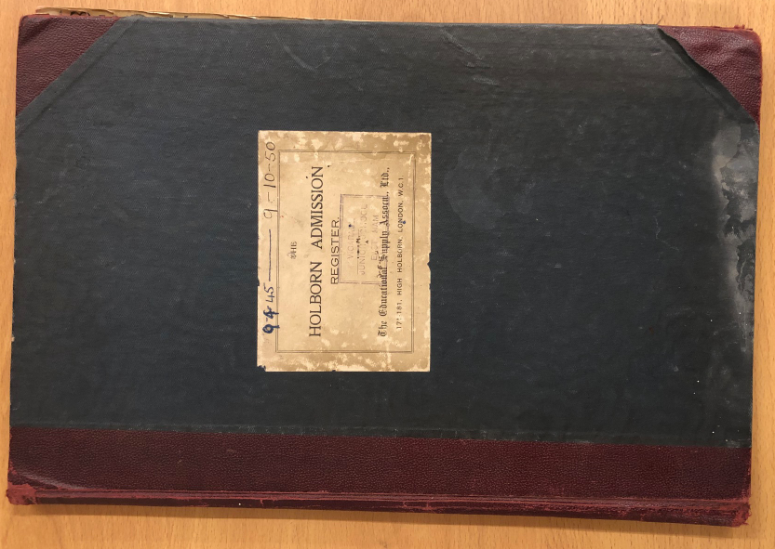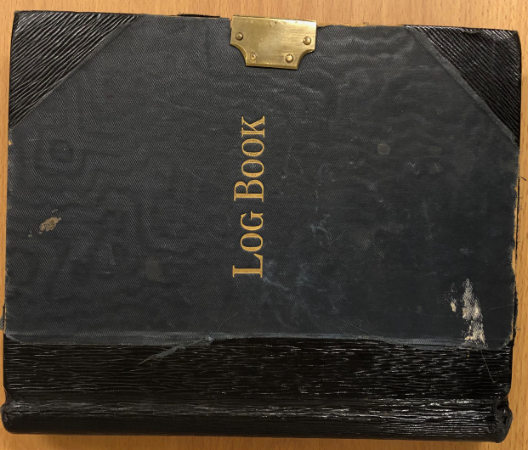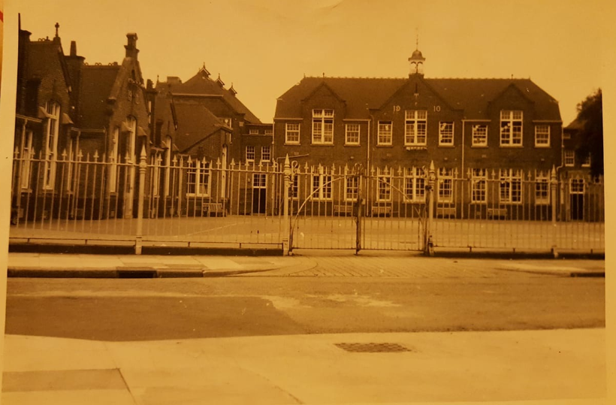
1970s
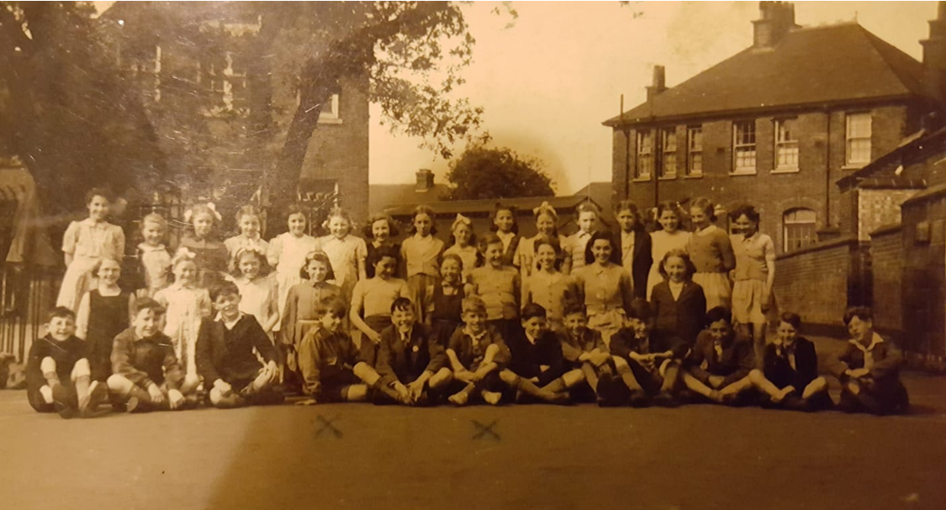
1946
Looking back at these wonderful artefacts has shown how much life has changed here at Vicarage. We will be exploring the artefacts further to see how much more we can find out. The Vicarage historians will be hard at work this term delving into our own history!

Have a look yourselves and see how life has changed!
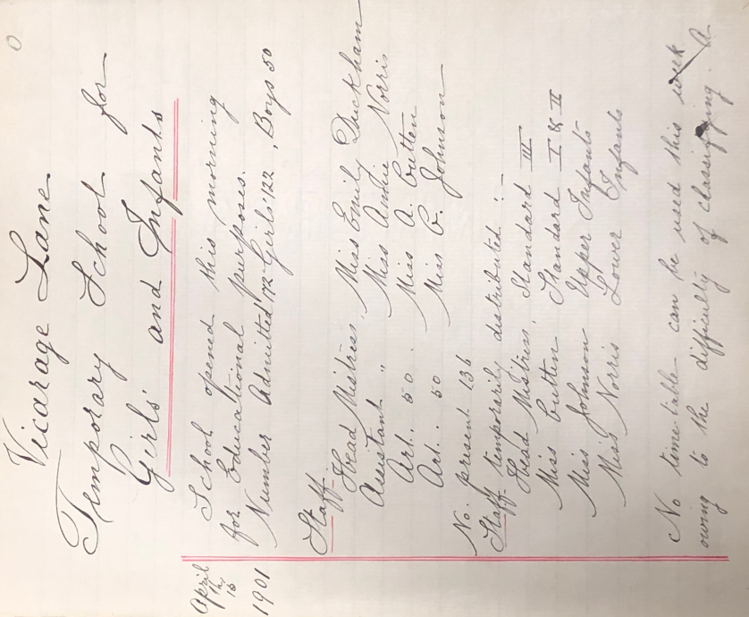
Vicarage Lane School opens for girls and Infants
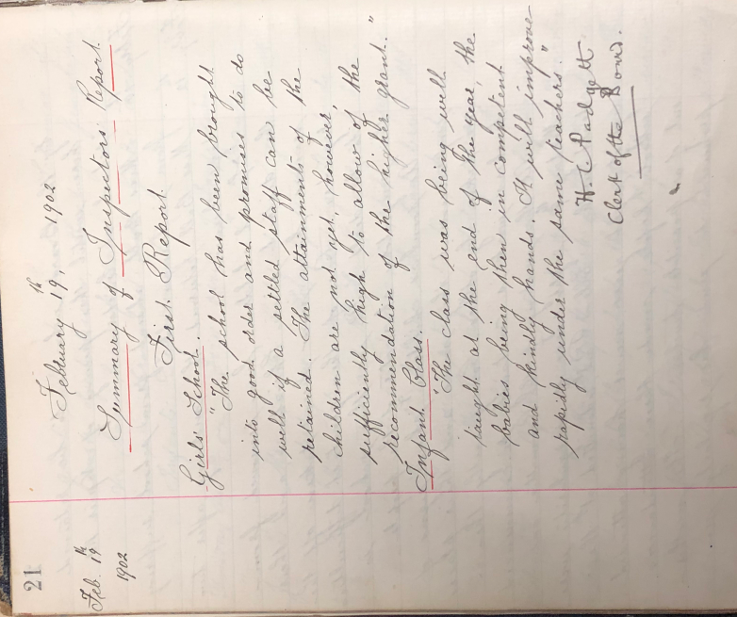 Vicarage Lane’s first inspection report!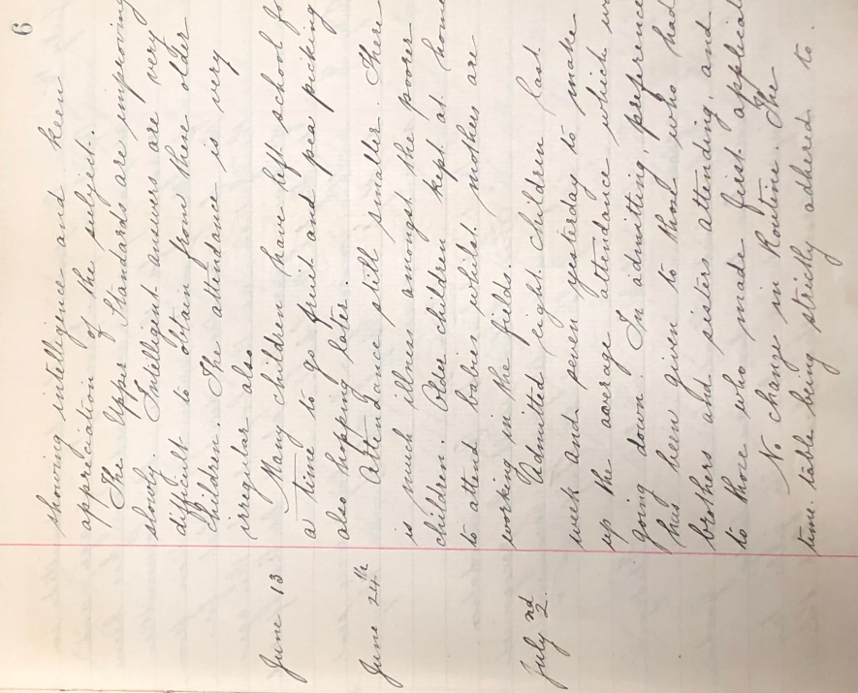
Attendance was low due to poor children being ill and other older children having to help look after the family as the parents were working in the fields.
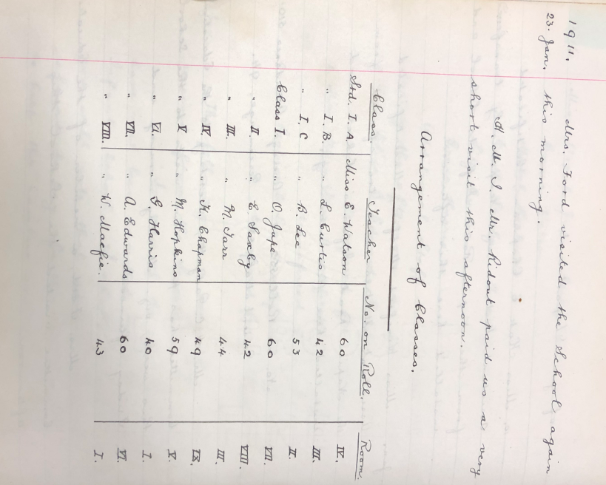 Classes of 50+ children!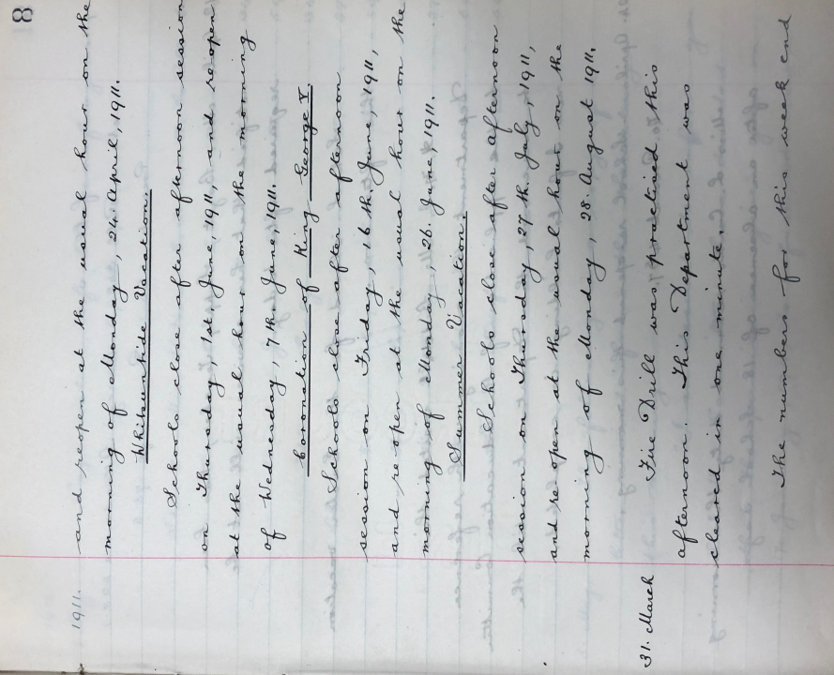
King George V’s coronation – School closed for the day.
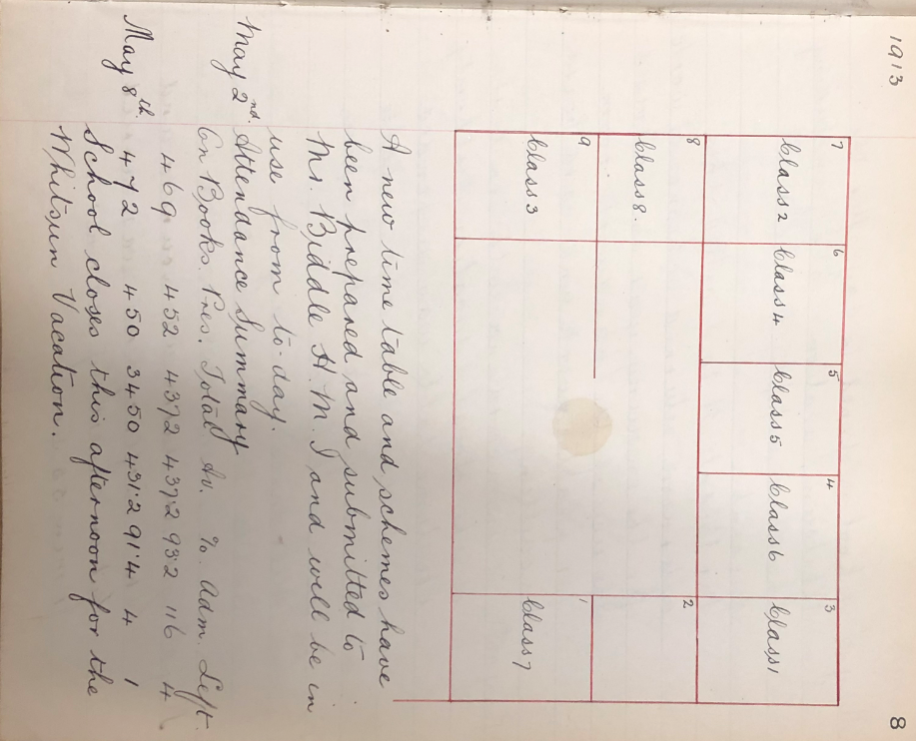
1913 Vicarage School is getting larger at 450 children. Only 8 classes means class sizes of 50+
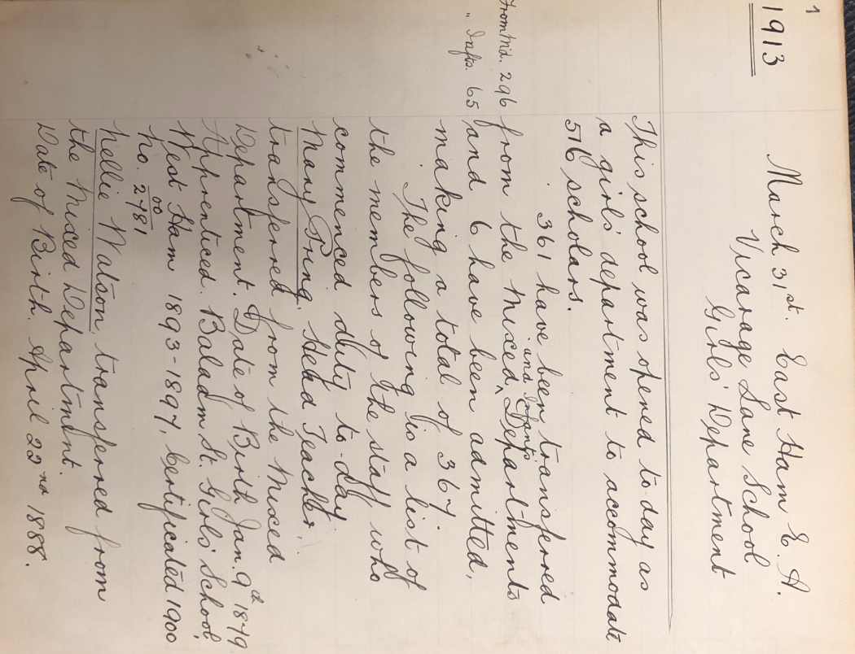
1913 School’s attendance is up to 570+

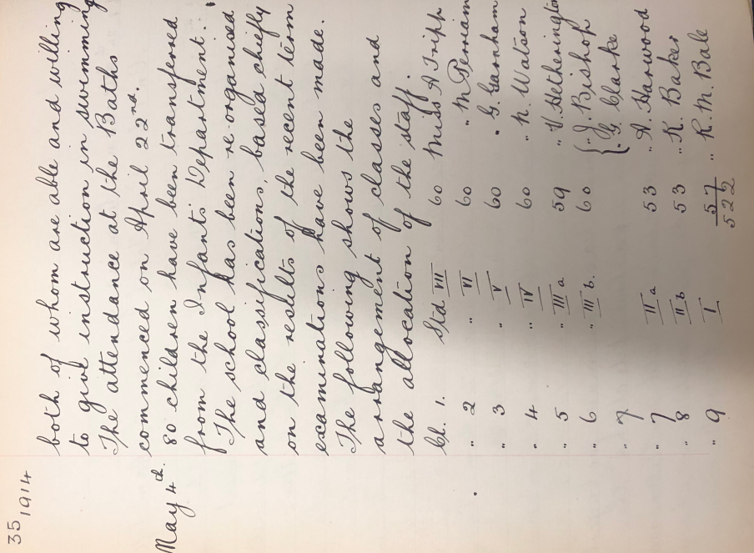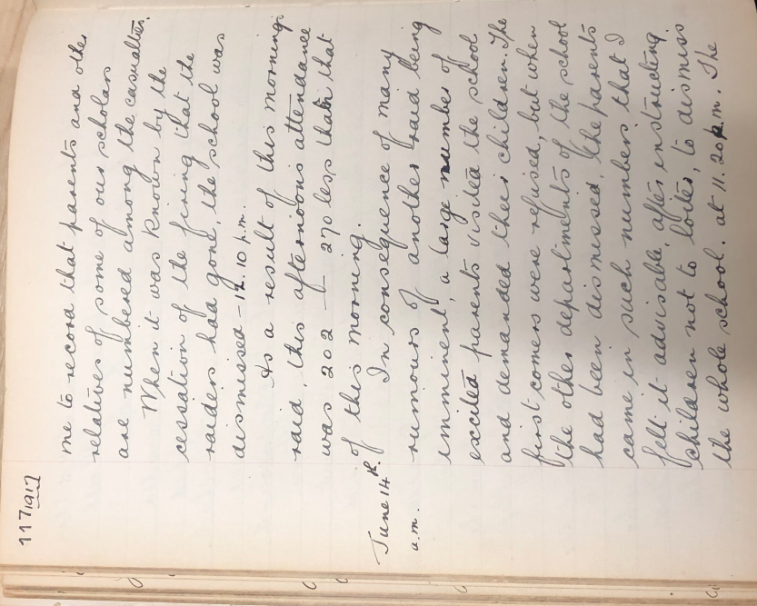
1917 Attendance is down to 202 due to bombing raids overnight. Families of Vicarage Lane among the casualties. Parents were keeping their children at home or wanting to take them out of school. School closed at 11.20am on the 14th June 1917.
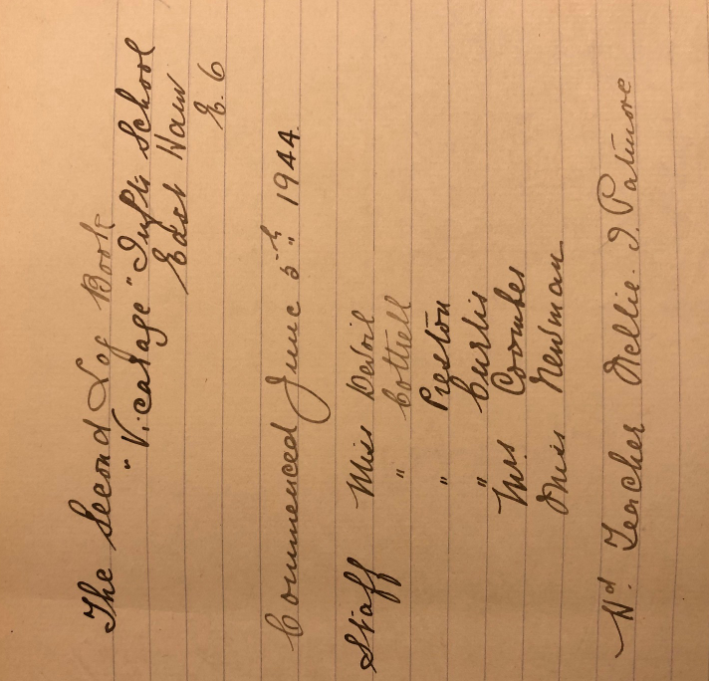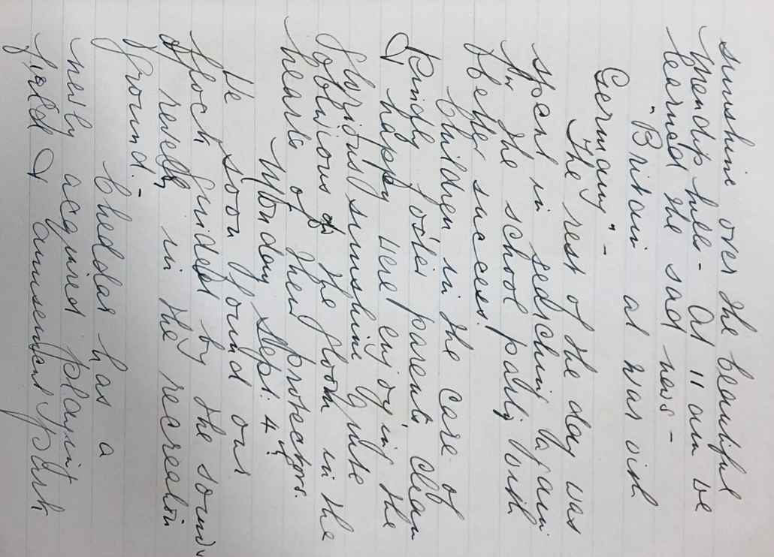
Declaration that Britain was at ‘War with Germany’
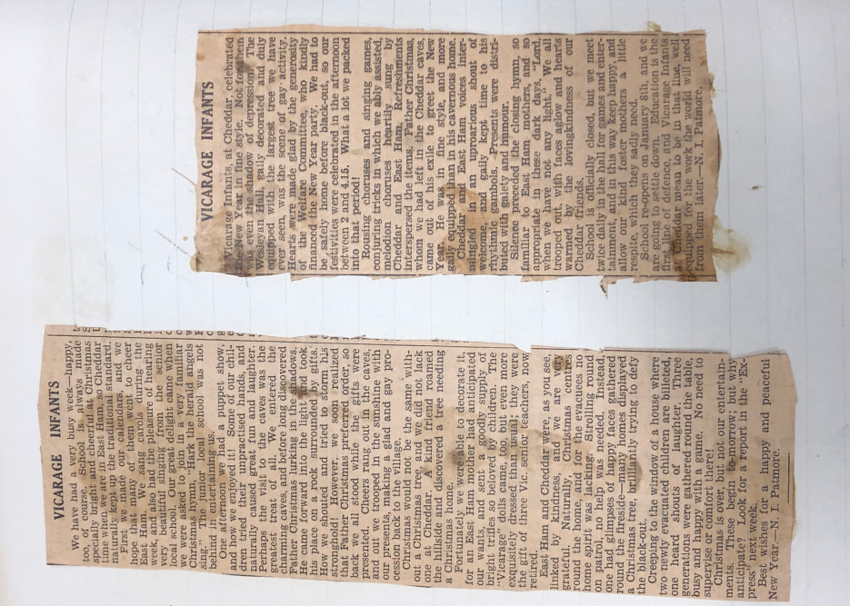 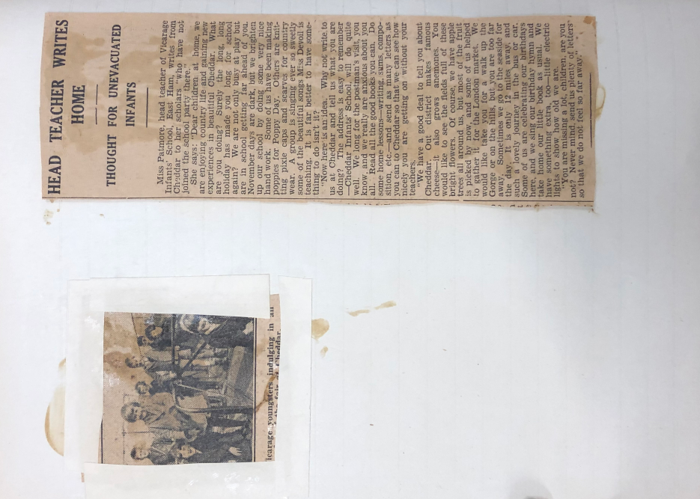 Extracts of newspapers about Vicarage Lane evacuees being sent to Cheddar in Somerset to escape the bombings in London.
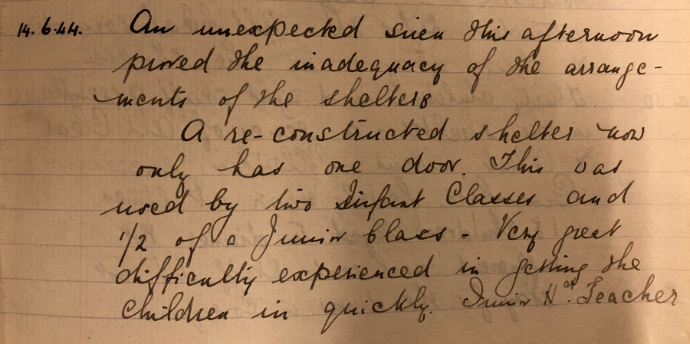 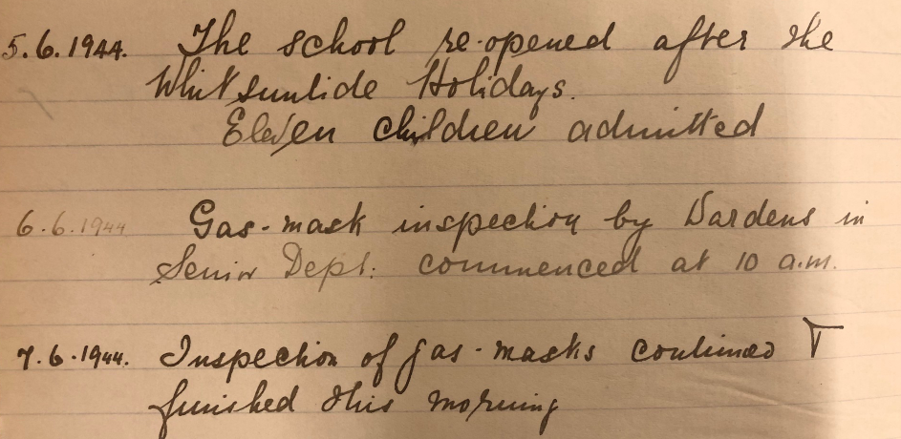 Air raid drills and gas mask inspecttions were a part of daily life at Vicarage Lane during WW2. 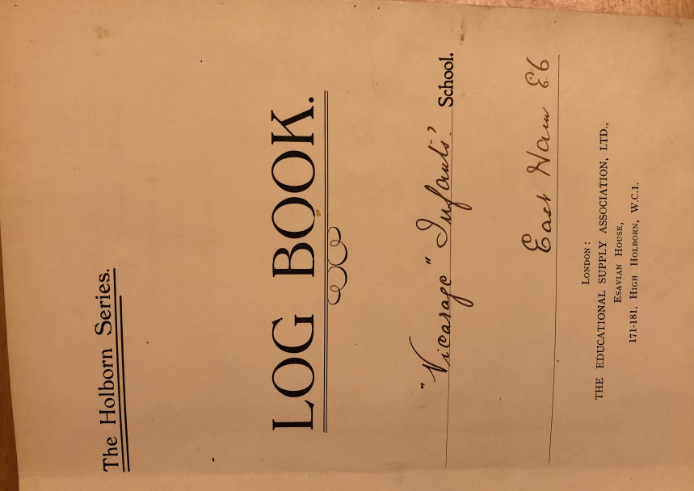
1957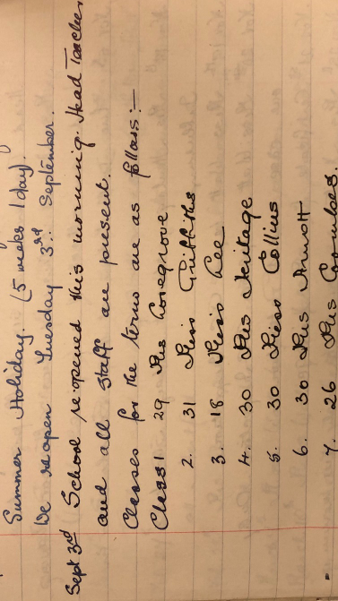
1960s
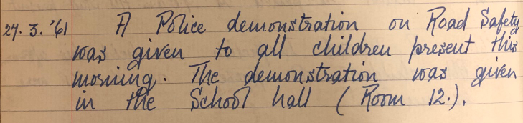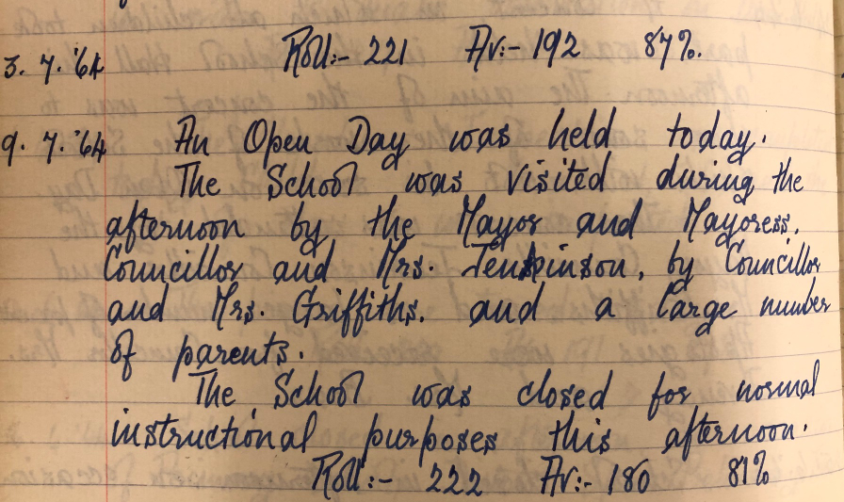
The mayor visited! Children attending school was down to 220.

We have also been lucky enough to have alumni from Vicarage send in their memories and photos!
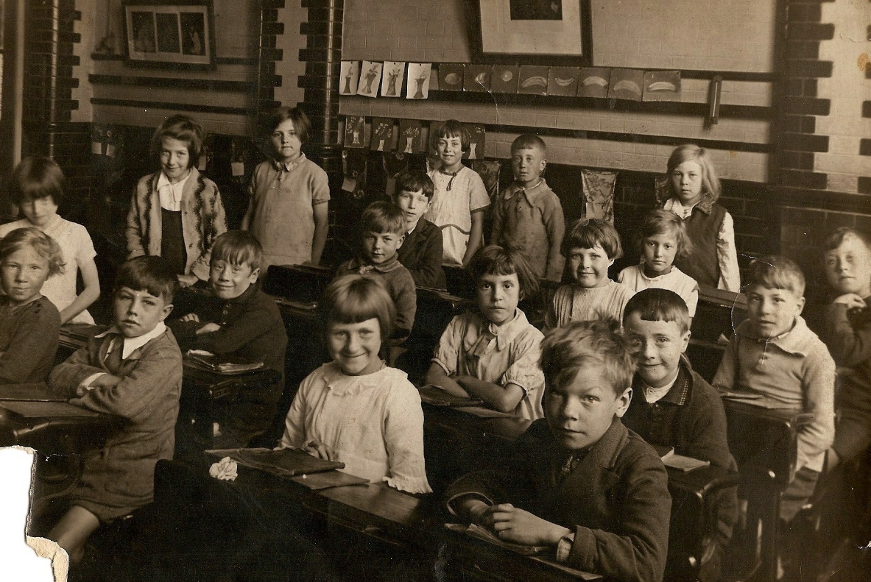
1931
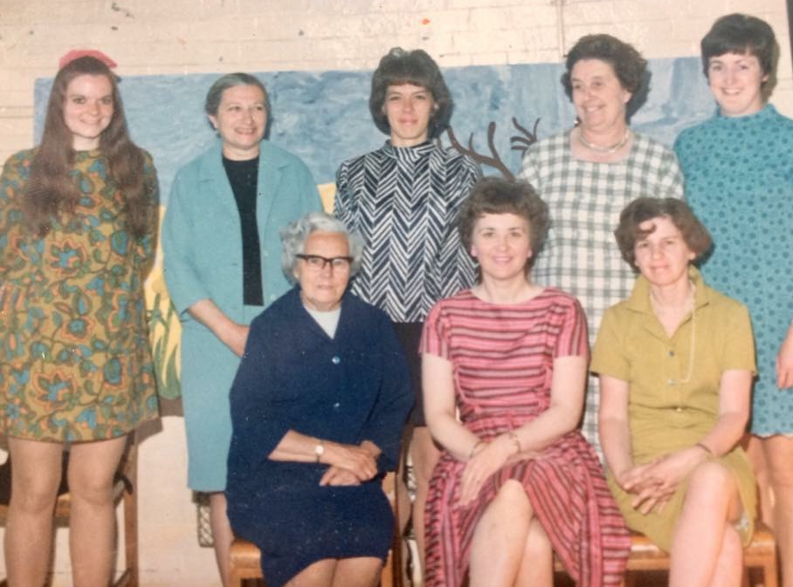
1970’s
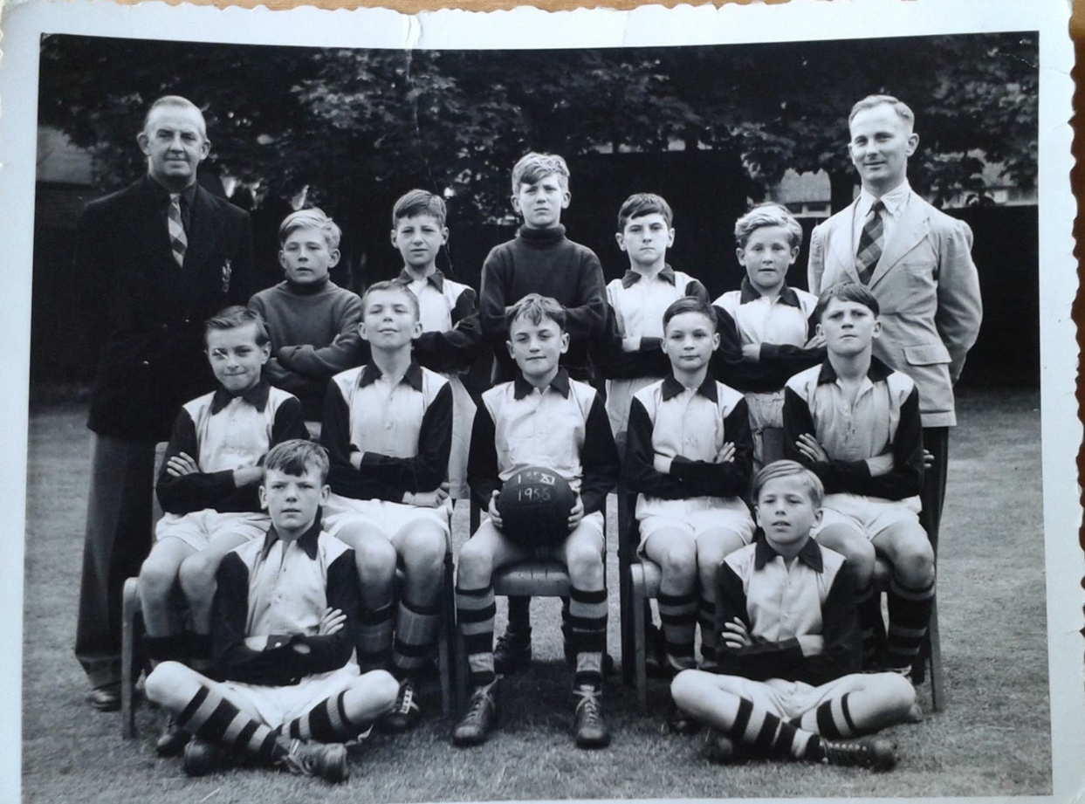
1956 Boys football team

