Father’s Day Event
On Friday 14th June, Reception classes celebrated ‘Father’s Day’ and welcomed fathers and male family members for a stay and play. It was a wonderful event for all who participated.
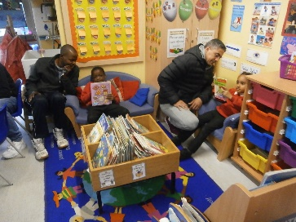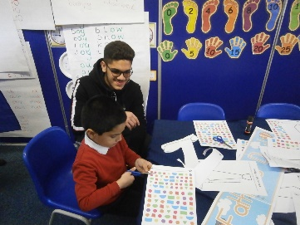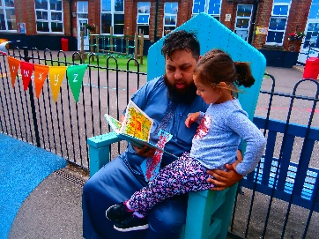
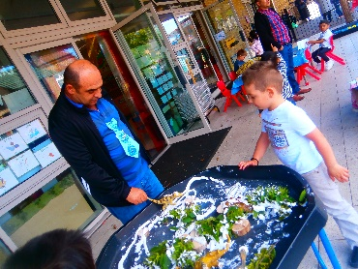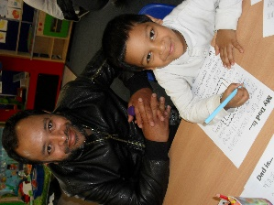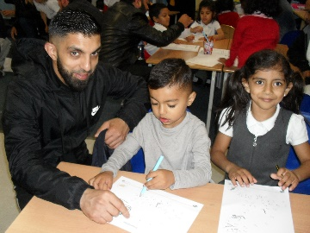

Chess Tournament

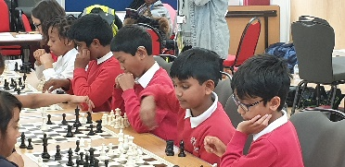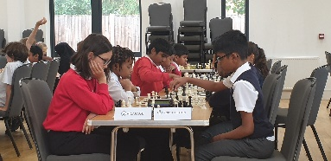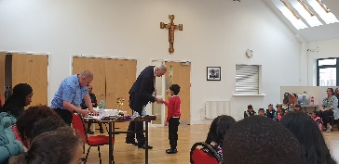

On Thursday 13th June, 9 pupils from Vicarage took part in a chess tournament at St Joachim's Primary School. The pupils played exceptionally well against seven other schools, coming third overall. Many congratulations to all the pupils, especially to Hawwa, Avyan and Sahol who were presented with individual medals for winning many of their matches. Well done to the team, who were:
Afina in 5I Dakarai in 5I
Jason in 4M David in 4C
Sahol in 4M Hawwa in 5P
Malina in 3A Avyan in 3B
Yahia in 3M

Cricket Final

We are thrilled to inform you that our Year 6 girls cricket team have reached the London Youth Games cricket final, which will be taking place on Wednesday 26th June. We wish them all the best.

Attendance and Punctuality Reminder
All children are expected to attend school regularly and on time. We ask you to ensure your child is in school at 8:45am, as this is the time children are able to gain entry to class. This gives them time to hang up their coat and say hello to their friends and be ready to start learning from the start of the school day, which is 8:55am. If your child arrives just 5 minutes late each day, they will be missing nearly 16 hours education over the course of a school year. Children arriving late miss important information at the start of the lesson. They are often embarrassed by continual lateness and this can affect their self-esteem. Our school gates are locked promptly at 9:00am. Children arriving after this time must report to the school office to get their registration mark. You will be asked to provide a reason for your child’s lateness.

Please consider carefully if your child needs to take a day off school. Missing areas of the curriculum will leave gaps in their education which has a negative impact on progress and attainment.
- Make arrangements for travel during school holiday times.
- Where possible, medical appointments should be outside of school hours. You must provide medical evidence to cover such appointments.
- Please contact us if your child is absent.

Dates for your Diary
Tuesday 2nd July- Years 5/6 Sports Day – 9.30am–11.45am / Years 3/4 Sports Day – 1.30pm-3.00pm
Wednesday 3rd July – Years 1/2 Sports Day – 9.30am-11.45am / Reception Sports Day – 2.00-3.00pm
Wednesday 10th July – Year 6 performance to parents – 5pm
Thursday 18th July – Class parties - pm
Friday 19th July – Last day of Term 6 and academic year for all pupils
Mrs S Khan
Head Teacher

